URGENT Call for a Servant of God!
July 13th, 2023

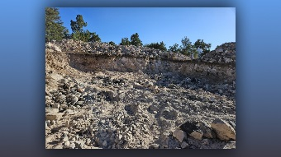
Greetings dear Heartdwellers, we are sending out this urgent call for a servant of God to help John continue to build the Lord’s desert refuge! We are in desperate need of another pair of hands and the resources to keep the community house moving forward. If there are any brothers out there who feel led to help us for a week or two or more, please reach out to us at desertheartdwellers@gmail.com.

That’s desertheartdwellers@gmail.com. As it is written in Isaiah 6:8, “Then I heard the voice of the Lord saying, “Whom shall I send? And who will go for us?” And I said, “Here am I. Send me!”

We are so very grateful for your support and outpouring of prayers to complete this sister community to the mountain refuge. We thank you from the bottom of our hearts for your encouragement to progress forward in His work.

May God bless you and guide you dear Family!

